Putin exploits the lie machine but didn’t invent it. British history is also full of untruths
George Monbiot
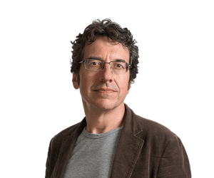
Our own crisis of truth is responsible for some of the world’s biggest problems
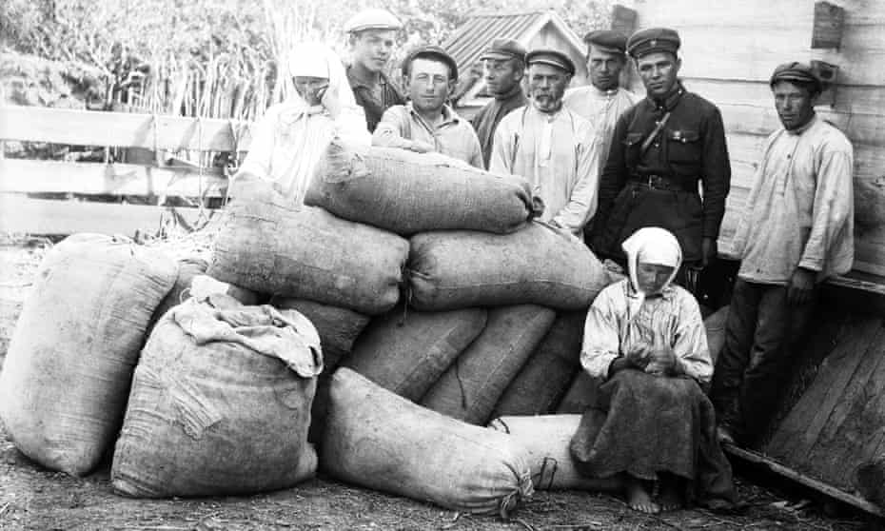
‘During the Holodomor the Kremlin line was that the peasants had plenty of food, but they were hiding it.’ Photograph: CPA Media Pte Ltd/Alamy
Wed 30 Mar 2022 08.00 BST
To the Syrians who have suffered its attacks, the Kremlin’s lies about Ukraine must sound horribly familiar. Insisting that the victims of bombings are “crisis actors”, spreading falsehoods about chemical weapons, justifying the mass murder of civilians by claiming that anyone who resists is a “Nazi” (in Ukraine) or a “head-chopper” (in Syria): its disinformation tactics have been tested and honed.
This organised lying has more or less destroyed the US left, and severely damaged the European left. As the activist Terry Burke documented in 2019, effective leftwing opposition to Donald Trump collapsed amid furious internal disputes about Syria and Russian interference in US politics, triggered by prominent figures reciting Kremlin falsehoods. Some of them turned out to be paid by the Russian government.
Such lies are also familiar to Ukrainians. During the Holodomor (the famine in the 1930s exacerbated by Joseph Stalin’s policies), in which between 3 and 5 million people are believed to have died, the Kremlin line was that the peasants had plenty of food but were hiding it. In some cases, they were deliberately starving themselves to death. I guess you could call it method crisis acting.
The current Russian disinformation machine has been widely blamed for what we now see as an “epistemic crisis” – the collapse of a shared acceptance of the means by which truth is discerned.
We should contest and expose the Kremlin’s lying. But to suggest that the public assault on truth is new, or peculiarly Russian, is also disinformation. For generations, in countries such as the UK there was no epistemic crisis – but this was not because we shared a commitment to truth. It was because we shared a commitment to outrageous lies.
As I’ve mentioned the Holodomor, let’s take a look at another exacerbated famine: in Bengal in 1943-1944. About 3 million people died. As in Ukraine, natural and political events made people vulnerable to hunger. But here too, government policy transformed the crisis into a catastrophe. Research by the Indian economist Utsa Patnaik suggests the inflation that pushed food out of reach of the poor was deliberately engineered under a policy conceived by that hero of British liberalism, John Maynard Keynes. The colonial authorities used inflation, as Keynes remarked, to “reduce the consumption of the poor” in order to extract wealth to support the war effort. Until Patnaik’s research was published in 2018, we were unaware of the extent to which Bengal’s famine was constructed. Britain’s cover-up was more effective than Stalin’s.
The famines engineered by the viceroy of India, Lord Lytton, in the 1870s are even less well-known, though, according to Mike Davis’s book Late Victorian Holocausts, they killed between 12 and 29 million people. Only when Caroline Elkins’s book, Britain’s Gulag, was published in 2005 did we discover that the UK had run a system of concentration camps and “enclosed villages” in Kenya in the 1950s into which almost the entire Kikuyu population was driven. Many thousands were tortured and murdered or died of hunger and disease. Almost all the documents recording these great crimes were systematically burned or dumped at sea in weighted crates by the British government, and replaced with fake files. The record of British colonial atrocities in Malaya, Yemen, Aden, Cyprus and the Chagos Islands was similarly purged.
Just as the Kremlin requires a campaign of disinformation to justify its imperial aggression in Ukraine, the British empire also needed a system of comprehensive lies. Not only were our imperial crimes deleted from the record, but an entire ideology – racism – was constructed to justify the killing, looting and enslavement of other people.
At the end of his excellent BBC podcast series about QAnon, The Coming Storm, Gabriel Gatehouse lamented the loss of a “common frame of reference” and a “shared sense of reality”. I agree with him about the danger of conspiracy theories, but we should remember that when we last possessed a common frame of reference and a shared sense of reality, they were built on lies. Almost everyone in Britain believed that the empire was a force for good, and that we had a holy duty – the “white man’s burden” – to either crush or “civilise” those races we labelled “inferior” and “savage”. Almost everyone believed the lies of national heroism, the lies of the crown, the lies of the church and the lies of the social order.

It’s not too late to free ourselves from this idiotic addiction to Russian gas
George Monbiot

Read more

But most of us have emerged from that era, haven’t we? We’re more sceptical, less trusting now. Most of us recognise nonsense when we see it. Really? So how do we account for the fact that almost everyone in public life subscribes to the same set of preposterous beliefs? Let’s set aside the wild conspiracy theories of the far right, even though they’re now starting to infect the mainstream right. Let’s focus on the “acceptable” range of political opinion.
Nearly everyone who appears in the media, across almost the entire political spectrum, seems to accept that economic growth can and should continue indefinitely on a finite planet. Almost all believe that we should take action to protect life on Earth only when it is cost-effective. Even then, we should avoid compromising the profits of legacy industries. They appear to believe that something they call “the economy” takes priority over our life support systems.
They further believe that the unhindered acquisition of enormous wealth by a few people is somehow acceptable. They believe that taxes sufficient to break the cycle of accumulation and redistribute extreme wealth are unthinkable. They believe that permitting a handful of offshore billionaires to own the media, set the political agenda and tell us where our best interests lie is fine. They believe that we should pledge unquestioning allegiance to a system we call capitalism even though they are unable to define it, let alone predict where it might be heading.
No terror or torture is required to persuade people to fall into line with these crazy beliefs. Somehow our system of organised lying has created an entire class of politicians, officials, media commentators, cultural leaders, academics and intellectuals who nod along with them. Reading accounts of 20th-century terror, it sometimes seems to me that there was more dissent among intellectuals confronting totalitarian regimes than there is in our age of freedom and choice.
We have a truth crisis all right. But it is much deeper and wider than we care to admit. Perhaps the biggest lie of all is that the crisis is confined to the Kremlin’s falsehoods and the far right’s conspiracy theories. On the contrary, it is systemic and almost universal.
- George Monbiot is a Guardian columnist. He will discuss Regenesis at a Guardian Live event on Monday 30 May. Book tickets in-person or online here
https://www.theguardian.com/commentisfree/2022/mar/30/putin-lie-machine-history-untruths

